*`Okinawa Memory Initiative*

*The Okinawaners*

**Sprint 1 Planning**

**Sprint Completion Date:** 10/21

**Revision:** 1.1

**Revision Date:** 10/21

**Product Owner:** Kevin Tran

**ScrumMaster:** Jeff Liao

**Team:** Kevin Tran, Ankita Upadhyay, Tina Peng, Alfred George Francisco Milan III, Wellford Chan

**Goal:** To build a website for the Okinawa Memory Initiative.

1. History archive. Host 9000+ documents for easier access.
2. Search docs by name, tags...
3. Related events, announcements.
4. Membered user could able to share docs, pics, medias on website.

**User Story 1:**

As an Okinawa Memory initiative (OMI) website user, I want to be able to able to access the About page, so that I can have an understanding on the project.

Task 1.1: Install React and Bootstrap (1 hour)

Task 1.2: Create the About page (2 hours)

Task 1.3: Create content for the about page. (2 hour)

**User Story 2:**

As an user, I want to be able to be able access the header, so that I can navigate to different page.

Task 2.1: Design UI for the header (2 hour)

Task 2.2: Include Home, About, Vault, Donate, Gail Project, and Document page within the header. (3 hours)

Task 2.3: Create backend skeleton with Amazon Web Servicve (6 hours)

*Task PRIORITY #: Task DESCRIPTION. (TIME IN HOURS) DIFFICULTY*

Task Breakdown:

Task 1: Design UI (3) 2

Task 2: Homepage (2) 5  
Task 3: Header (1) 2

Task 4: Footer (1) 2

Task 5: About (1) 5

Task 6: Document Page (?) 5

Task 7: Archived Page (6) 5

Task 8: Login Page () 13

Task Breakdown:

Task 1: User Login (3) 5

Task 2: Design user object (2) 5

Task 3: Design document object (2) 5

Task 4: API to post/get documents (2) 5

Task 5: Integrate API with FE (2) 5

Task 6: Connect to Database (5) 5

Task 7: API to list docs for search (5) 5

Task 8: API to post/get announcements (5) 5

**Team Roles:** *Name: Main Role, {Secondary Role}*

Kevin Tran: Project Owner, {UI design, Frontend}

Jeff Liao: Scrum Master, {Frontend}

Tina Peng: Frontend {UI design, Backend}

Wellford Chan: Backend {Frontend}

Ankita Upadhyay: Backend {Frontend}

Alfred George Francisco Milan III: Full Stack

**Task Assignments:**

Kevin Tran: (User Story 2: Task 3. Task 4. Task 5)

Jeff Liao: (User Story 2: Task 1, Task 2, Task 6)

Tina Peng: (User Story 1: Task 1,Task 2, Task 5)

Wellford Chan: (User Story 1: Task 8; User Story 2: Task 7, Task 8)

Ankita Upadhyay: (User Story 1: Task 3, Task 4, Task 7)

Alfred George Francisco Milan III: (User Story 1: Task 6, Task 7)

**Initial Burnup Chart:**

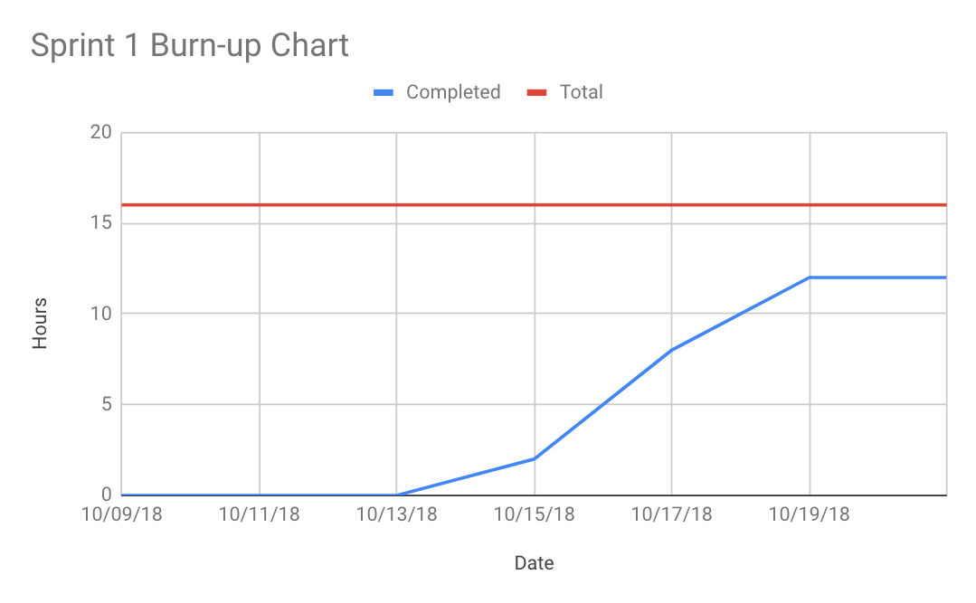

**Initial Scrum Board:**

|  |  |  |  |
| --- | --- | --- | --- |
| Stories | ToDo | In Progress | Done |
| #1: View related documents, events, announcements related to Okinawa culture/history | * UI * Homepage * Header * Footer * About * Document Page * Archived Page * Login Page |  |  |
| #2: User should be able to share experiences in Okinawa culture (comment, share, contribute to the discussion forum) | * User login * Design user object * Designer post object * API to post/get documents * Integrate API with FE * Connect to database * API to list docs for search * API to post/get announcements |  |  |

**Scrum Times:** (SNE bottom floor) ~1hr long

Tuesday 3:30pm

Thursday 2:00pm

Sunday 7:00pm

____________________________________________________________________________

***Side Notes for the Team:***

**Front End Pages:** Home, login (Google Sign-in), about (and contact), document page, archived page, header, footer

**Must have:** First Five tasks of user story 1

**Should have:** Task 1-8 of user story 1

**Could have:**  Task 1-3 of user story 2

**Won’t have:** Task 1-8 of user story 2

____________________________________________________________________________